**Figure 1a. 2023 West Nile Virus Surveillance Vector Index for all *Culex* by FC zone (2007-2023).**

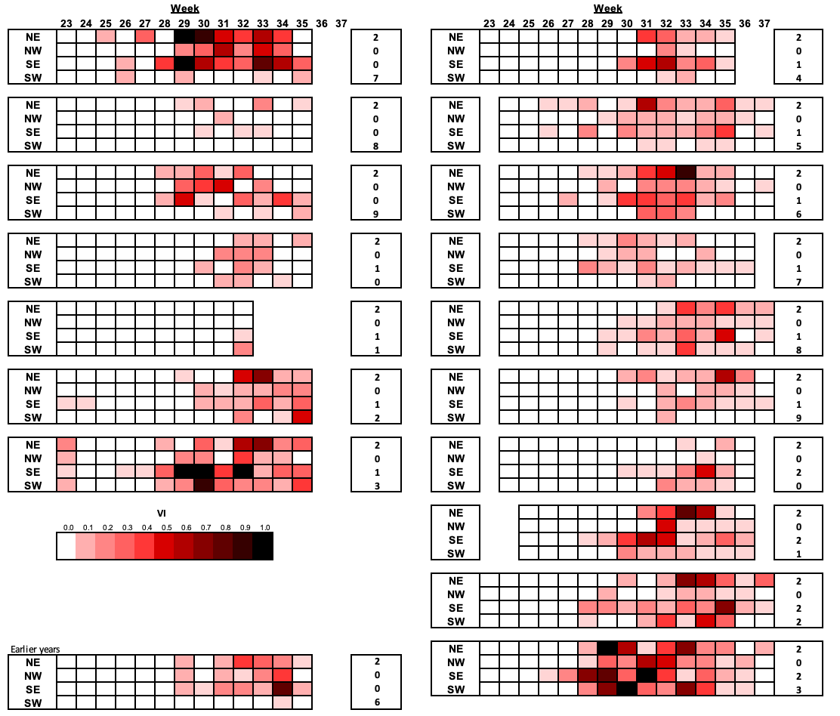

**Figure 1b. 2023 WNV surveillance Citywide Vector Index in relation to (2006-2022) historical verages.**

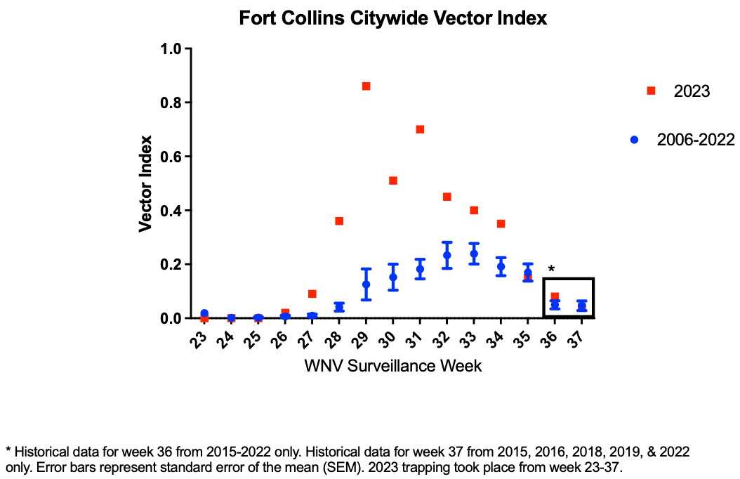

**Figure 1c. 2023 WNV surveillance Citywide Vector Abundance in relation to (2006-2022) historical averages.**

